Title: Coffee Chain Sales Analysis Report

Date: October 08, 2023

Prepared by: Hemaraj.K

Executive Summary

This report analyzes the sales data for a coffee chain over the three-year period from 2012 to 2014. The data was analyzed using Excel to identify trends and patterns. The key findings of the report are as follows:

* The most popular coffee products are the Colombian, Lemon, and Decaf Espresso.
* The most profitable coffee products are espresso and coffee.
* Sales are increasing over time.
* Sales are highest in the West market.
* California has the highest sales over other products

Based on these findings, the following recommendations are made:

* The coffee chain should focus on promoting its most popular and profitable coffee product.
* The coffee chain should open new stores in urban areas to capitalize on the high demand for coffee in these areas.

Introduction

This report analyzes the sales data for a coffee chain over a three-year period, from 2012 to 2014. The data was analyzed using Excel to identify trends and patterns. The purpose of this report is to provide the coffee chain with insights into its sales performance and to make recommendations for how to improve sales performance.

Methodology

The data for this report was collected from the coffee chain's sales records. The data was then cleaned and prepared for analysis using Excel. The following steps were taken to analyze the data:

1. The data was summarized by product category, product type,States,Months and Markets.
2. Charts and graphs were created to visualize the data.

Results

The key findings of the report are as follows:

* The most popular coffee products are the Colombian, Lemon, and Decaf Espresso.

| Most Profitable Coffee products: |  |  |
| --- | --- | --- |
| **Coffee Product** | **Total Sales** | **Total Profit** |
| Colombian | 30761 | $12,932.00 |
| Lemon | 24048 | $7,614.00 |
| Decaf Espresso | 18888 | $7,039.00 |
| Chamomile | 19295 | $7,006.00 |
| Darjeeling | 17758 | $6,976.00 |
| Earl Grey | 16546 | $5,975.00 |
| Caffe Mocha | 21716 | $4,687.00 |
| Regular Espresso | 6744 | $3,438.00 |
| Decaf Irish Cream | 14831 | $3,201.00 |
| Caffe Latte | 8665 | $2,716.00 |
| Amaretto | 6781 | $1,352.00 |
| Mint | 8342 | $1,286.00 |
| Green Tea | 8520 | $89.00 |
| **Grand Total** | **202895** | **$64,311.00** |

* The most profitable coffee types are espresso and coffee.

| Most Popular Coffee Type: |  |
| --- | --- |
| **Coffee Type** | **Total Sales** |
| Espresso | 56013.00 |
| Herbal Tea | 51685.00 |
| Tea | 42824.00 |
| Coffee | 52373.00 |
| **Grand Total** | **202895.00** |

* Sales are increasing over time.

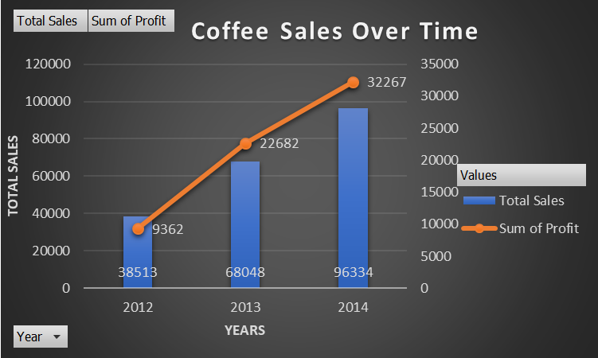

* Sales are highest in California, with total sales of 67,418.

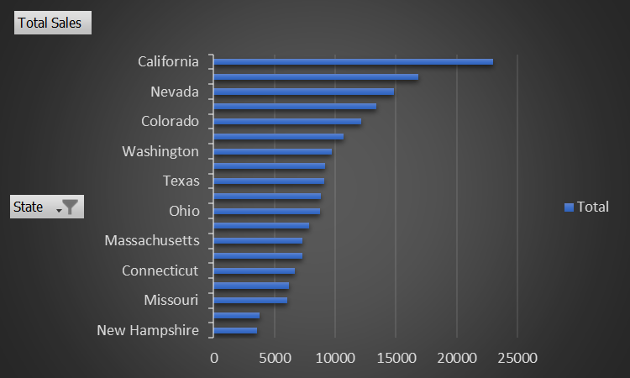

Discussion

The findings of this report suggest that the coffee chain is performing well overall. Sales are increasing and the most popular and profitable products are well-identified. However, there are a few areas where the coffee chain could improve its sales performance.

First, the coffee chain could focus on promoting its most popular and profitable coffee products. This could be done through marketing campaigns, discounts, and special promotions.

Second, the coffee chain could expand its hours of operation to capture more sales in the evening. Many people work late or have other commitments during the day, and they may be more likely to purchase coffee in the evening.

Third, the coffee chain could open new stores in West Market. West Markets typically have a high density of people, and they tend to have a high demand for coffee.

Recommendations

Based on the findings of this report, the following recommendations are made:

* The coffee chain should focus on promoting its most popular and profitable coffee products.
* The coffee Chain should focus on products which need improvement.
* The coffee chain should expand its hours of operation to capture more sales in the evening.
* The coffee chain should open new stores in West Market.

In addition to the above recommendations, the coffee chain could also consider the following:

* Offering loyalty programs to reward customers for repeat business.
* Partnering with local businesses to offer discounts or promotions to customers.
* Investing in social media marketing to reach a wider audience.

By implementing these recommendations, the coffee chain can increase its sales and profitability.

Conclusion

This report has analyzed the sales data for a coffee chain over a three-year period, from 2012 to 2014.The key findings of the report are that the most popular coffee products are the Colombian, Lemon, and Decaf Espresso, the most profitable coffee products are the espresso and coffee, sales are increasing over time,and sales are highest in West Market. Based on these findings, the following recommendations are made: the coffee chain should focus on promoting its most popular and profitable coffee products, expand its hours of operation to capture more sales in the evening, and open new stores in the West Market.